WELCOME TO CUB SCOUT PACK ___________

We meet on: _____________________________ at ________________________
Our meeting location is: _______________________________________________
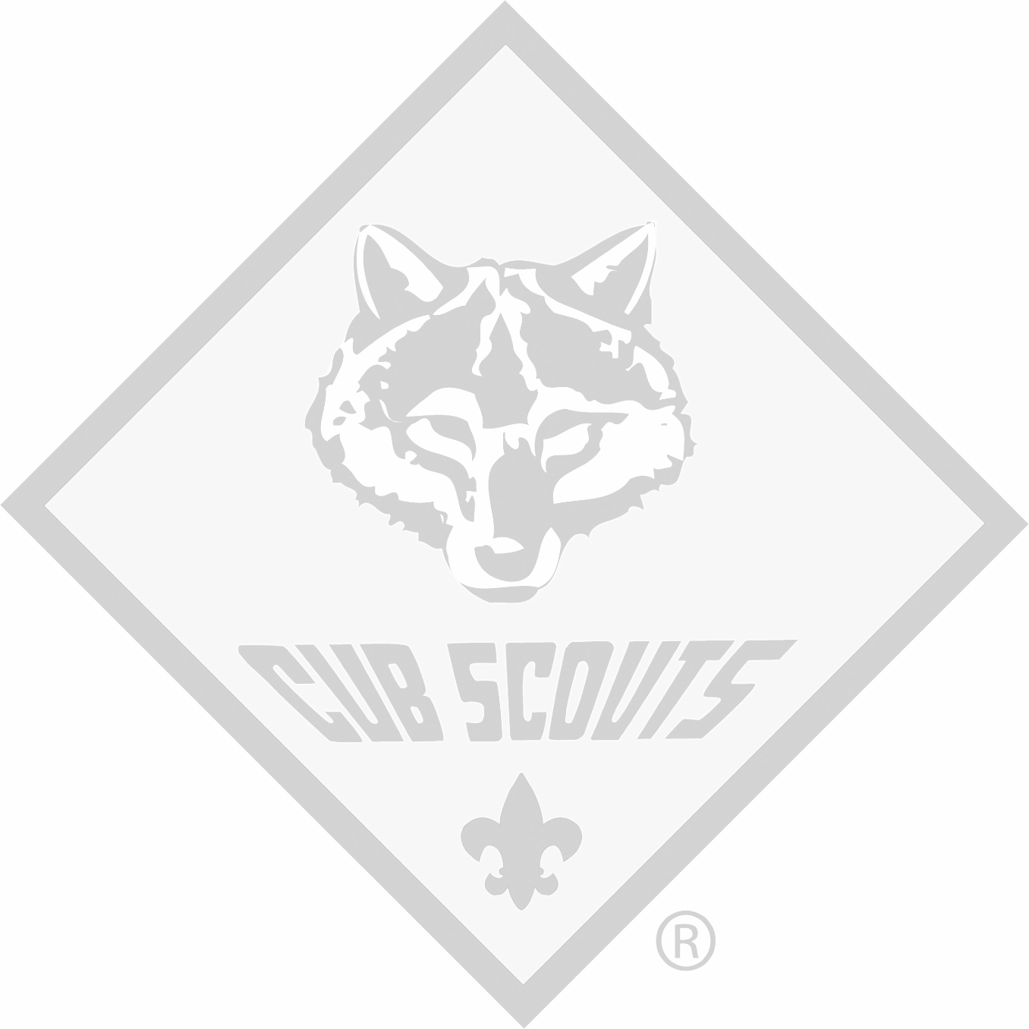
Our Cubmaster is: ____________________________________________________
Phone: ____________________ Email: __________________________________
This is the adult who will run meetings for your Pack, the larger group of Scouts will meet once a month. A Pack includes Cub Scouts from multiple dens and grades.

Our Den Leader is: ____________________________________________________
Phone: ____________________ Email: __________________________________
This is the adult who will run meetings for your den. Your Cub will meet with their den – a smaller, grade-specific group - several times each month when there is no Pack meeting

If I have questions about Cub Scouts, I can call or email:
Name: ____________________________________________________
Phone: ____________________ Email: __________________________________
Our Pack website: ____________________________________________________
Our most used social media page: _______________________________________

I can get uniforms, books and other equipment at:
Eugene Scout Shop Central Point Scout Shop
2525 Martin Luther King Jr. Blvd. 3039 Hanley Rd
Eugene, OR 97401 Central Point, OR 97502
Eugene: Open Mon 9a-5p, Tue-Fri 9a to 6p and Saturdays from 10 to 2 (except Duck Home Games)
Central Point: Open Tuesday 10a-6p, Wed-Fri 10a-5p, Closed 1-1:30 for lunch

