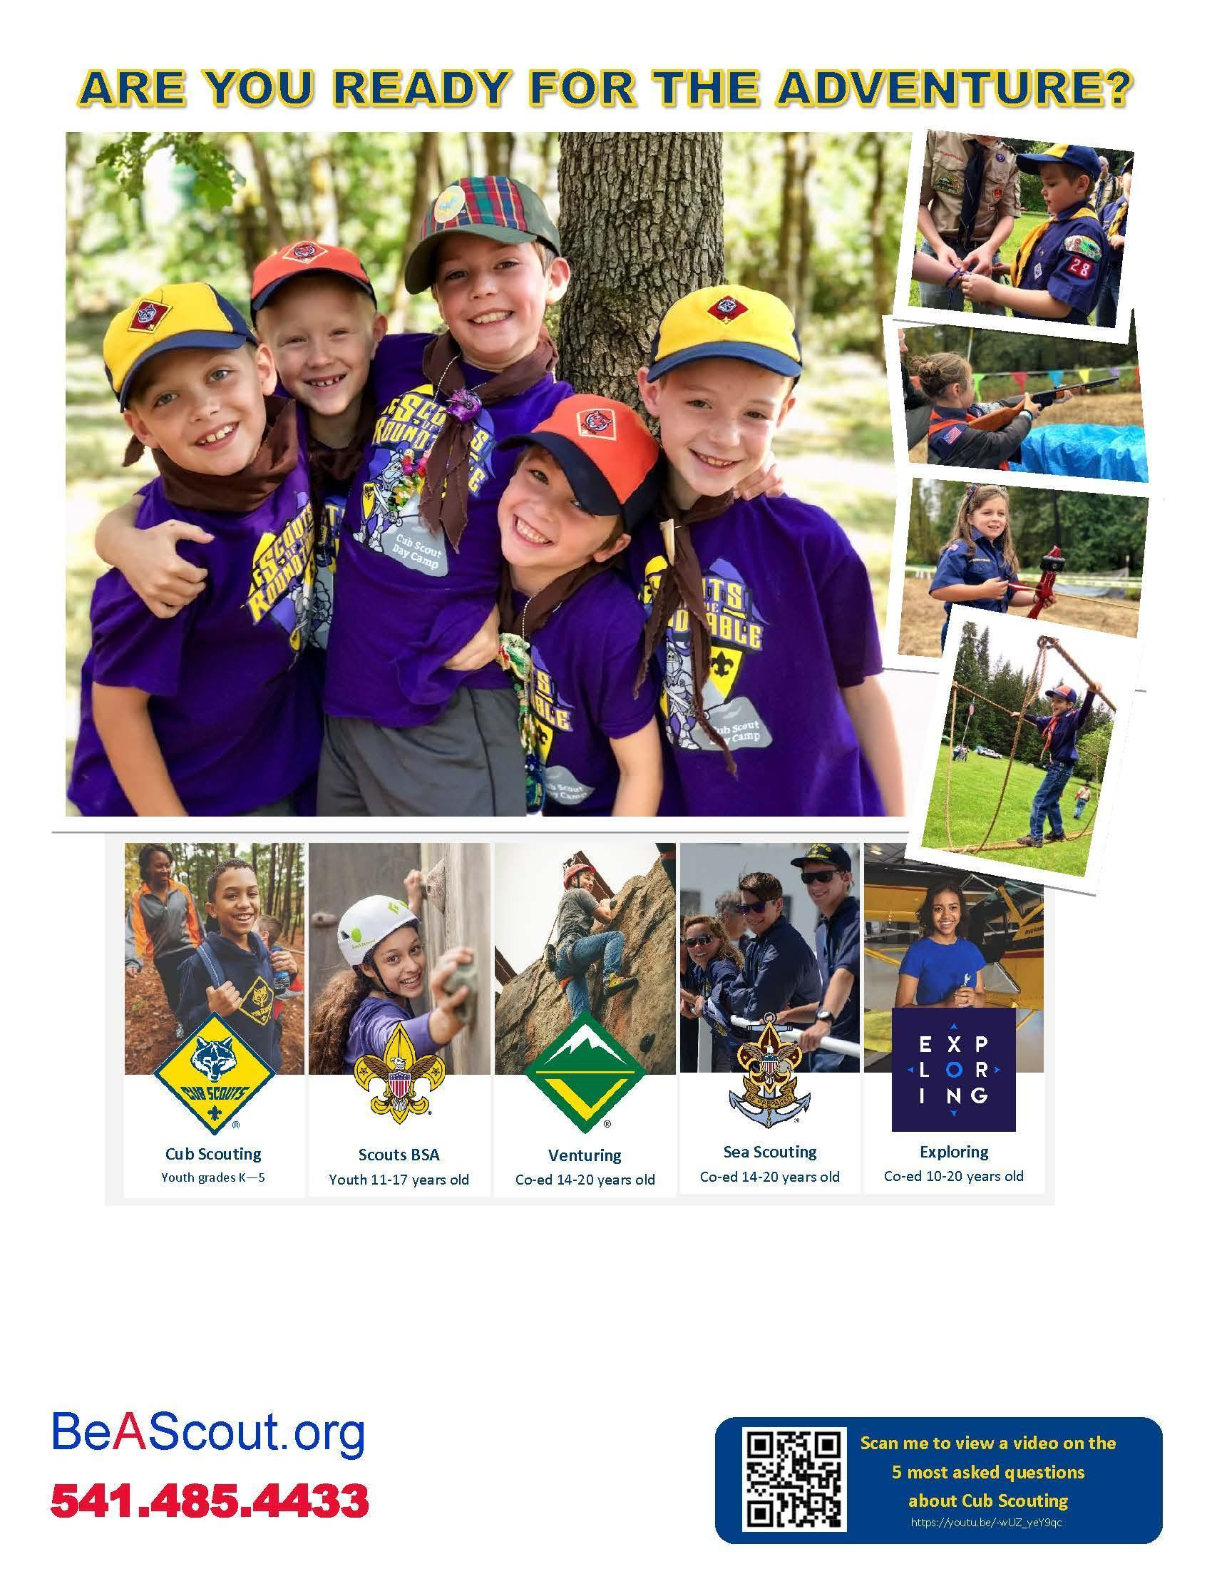
Monday, September 14th
6:30 PM
School Cafeteria
You’re invited to join Cub Scouts! Cub Scouting is for boys and girls in Grades K-5.

Contact: Cubmaster at (XXX) XXX-XXXX or cubmasteremail@pack123.com

